Hitching Mechanics of the Tractor Chassis
Adapted from Physical Science Applications in Agriculture
Buriak and Osborne

Table Top Laboratory Activity

Materials needed:
- Objects to serve as a lever arm (i.e. 2”x2” or 1”x2” board length can vary between 3 and 4 ft)
- Object to serve as a fulcrum (i.e. cut a 2x4 to make a 45 corner. Lay hypothenuse parallel to the table top surface)
- Weights (i.e. washers, nuts, bolts, or pieces of metal)
- Scale for weighing materials
- Tape measure

Formulas:
Moment = Force applied x Distance of lever
Moment equilibrium formula: F_{a} x a = F_{b} x b

Main Idea: External forces acting on a tractor’s chassis may create instability resulting in a rear rollover

Learning Objectives (S.W.B.A.T):
Solve hitching and stability problems
Calculate a moment of force
Determine if tractor hitching is at equilibrium

Concepts to discuss:
Drawbar forces on tractors
Hitching procedures
Terminology associated with connecting implements

Leading Questions:
Is there a right way to connect implements to a tractor?
How do you connect implements to the tractor?
Have you ever wondered why we connect to the drawbar?

Station One: Explore the concept of moment equilibrium
At this station you will determine the magnitude of a moment (turning effect of a force). Magnitude of a moment is a product of force and the distance the force acts from the center of rotation. In our example the fulcrum will be the center of rotation. When moments are at equilibrium the should be no rotation of the lever.

Materials:
- Weights
- Lever (i.e. 1x2 board)
- Fulcrum
- Tape measure
- Scale

1.) Calculate the balancing force needed for equilibrium given the following formula and data. Show your work. (equilibrium formula: F_{a} x a = F_{b} x b)
a = 24 inches
F_{a} = 0.25 pounds
b = 12 inches
F_{b} = ___________

2.) Using materials provided demonstrate moment equilibrium between force applied and your calculated balancing force. The diagram below provides an example of how to set up the lever.
(b)
F_{b}
F_{a}
Balancing Applied Force
Initial Applied Force
M_{cc} = F_{a} x a
(moment counter-clockwise)
M_{c} = F_{b} x b
(moment clockwise)

(a)
Fulcrum

Station Two: Hitching Mechanics of the Tractor
At this station you will determine effect of hitching height on tractor stability.

The picture below is labeled with the external forces acting on a tractor pulling an implement
The point at which the rear tires contact the ground serves as the fulcrum. Lever arm length (b) is the distance from the fulcrum to the center of gravity for the tractor. The center of gravity represents the weight of the tractor. Lever arm length (a) is the distance from the fulcrum to the hitching point. Force applied to lever arm (a) is a combination of the draft force (drawbar pull = F_{x}) and the tongue weight or (downward force = F_{y}).

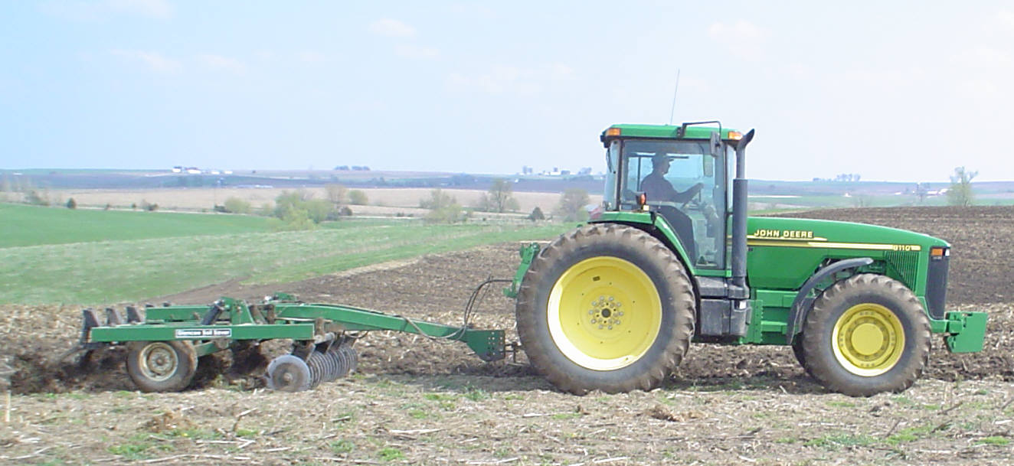For most tractors, F_{y} (dependent upon implement being pulled) and lever arm length (a) are fixed. However, F_{x} will change based on the drawbar height (y). The moment F_{x} is the product of drawbar pull and hitch height (Moment F_{x} = F_{x} x y).
(F_{y}) tongue weight or downward pull force
(F_{x}) draft force or drawbar pull force
a
weight of tractor (Wt)
b
This Photo by Unknown Author is licensed under CC BY-SA

Materials:
Model tractor (1/32 scale)
Rubber bands
Paper Clips
Tape Measure
Small diameter wooden dowels
Sand paper (for tractor wheel traction)

Design an experiment to determine the effect of varying hitch heights on tractor rear rollover stability. Complete a test using the standard drawbar hitching height and a hitching point above the drawbar height. Use the paper clips to create connection points on the tractor. Attach the rubber band to the hitch point and pull to apply a draft load. For each hitching point, measure and compare the lengths that the rubber band stretches before the tractor frontend lifts. You may need to chock the rear wheels to keep the tractor fulcrum from sliding (note using sand paper may provide increase traction of rear wheels).

Drawbar Hitching Point ______________________

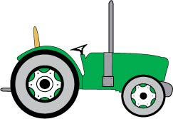
This Photo by Unknown Author is licensed under CC BY-NC
rubber band

Raised Hitching Point ________________________

rubber band
This Photo by Unknown Author is licensed under CC BY-NC

You may consider adding weights to the front wheels of the tractor and determine the effect of counter weights on tractor stability.

